Math modeling unit and activity - example layout of description
Activity name: Geometry in the Parking Lot
Big Idea(s)/ Concept(s)/major math area(s): Transversal Lines and angle relationships
Grade level(s): 9-12

Math (and science?) Standards included: G.PL.3: Prove and apply theorems about lines and angles, including the following: vertical angles are congruent; when a transversal crosses parallel lines, alternate interior angles are congruent, alternate exterior angles are congruent, and corresponding angles are congruent; when a transversal crosses parallel lines, same side interior angles are supplementary; and points on a perpendicular bisector of a line segment are exactly those equidistant from the endpoints of the segment.

Procedure overview/ teacher directions
Lesson details, expected timing, including:
Pre and post activities (student preconceptions, pre-knowledge etc);
teacher introduction to activity; guidance to students; math vocabulary
pre-discussion (usually whole group)
- Each day should last for 50 minutes.
- Students should have an understanding of mathematical notation, how to label lines, and how to label angles.
- Materials needed: measuring tape or meter sticks, large protractors or other device to measure angles.

Day 1
- Part 1 Initial whole group discussion - setting the scene
  - Today we are going to talk about lines, specifically lines in the parking lot. So let’s head outside. Set expectations for going outside as necessary. (3 minutes to get there)
- Part 2 Student group activity/pre-activity (with/without whiteboard)
Whole group discussion of part 1 activity - conclusions to be drawn from discussions about activity - these may be only qualitative or just introducing the “big ideas” - being developed by the students, with teacher guidance.
  - When class is outside, as a whole group discuss how the lines are set up. Have students point out specific things about the lines. Point out how some lines are straight, some are intersecting, lead students to talk about parallel lines. Afterwards, tell students that they will be in charge of finding a way to measure how long the lines are, and where we can find angles. We will walk around and find the most interesting parking lot. (7 minutes)
- Part 3 Student group activity (with/without whiteboard)
Whole group discussion of part 1 activity - usually a quantitative proof of the “big idea(s)”; conclusions to be drawn from discussions. These become mathematically quantitative - verified by the student-acquired data.
  - Students separate into groups of three in different parts of the parking lot and measure the angles. Students develop a method for measuring the lines and ways to mark where the angles are actually being formed (in the middle of the paint? On the edges?). Students will record how they decided to do these measurements. Students will also record how the lines are set up for at least four parking spots with measurements for how long the lines are and what the angles are and potentially take photos of the parking lot. (20 minutes)

- Part 4 Student group follow-up activity - there might be several of these, as the topic is extended in the unit....
  - Students return to the classroom with the measurements/photos. Students will transfer this information to a whiteboard that will summarize their finding. Teacher will have on the board: “What patterns can we notice from the parking lots in terms of lines and angles?” (10 minutes)

- Part 5 Final discussion (with/without whiteboard)
Generalizations, connections to other math topics, connections to real life
  - Students will show their whiteboards, pointing out how the angles work and noting patterns between the boards. Teacher will introduce geometric words as necessary (see standard). Teacher asks, “why are the parking lots designed like this? Are the better ways to design the parking lots? What issues do you notice about how the busses leave? Should we do things differently? (this will be followed up on the next day)” (10 minutes)

- Brief summary of how this unit fits into year’s curriculum and storyline (e.g preceding and post activity/units)
  - During this unit, we will explore how parallel lines are useful, but also how it will be useful to have lines intersect as well. We will explore what happens when lines cross, what angles do they form, and how we can relate, name, and use relationships between angles and lines. (1 minute)

- Homework
  - Students will answer a self assessment modeled after page of the Boaler text

Future days: What makes an efficient parking lot? Design a new parking lot for our school. Examine parking lots in popular spots (the mall, grocery stores…), decide if there is one place that has a horrible parking lot and present them with a solution that we design. (I like this idea!)

Question: Do transversals come into any other design problems?

Day 2: Foldable
- Students will create a foldable on this day that will aid in knowing the terms for angle pair relationships. (example below)
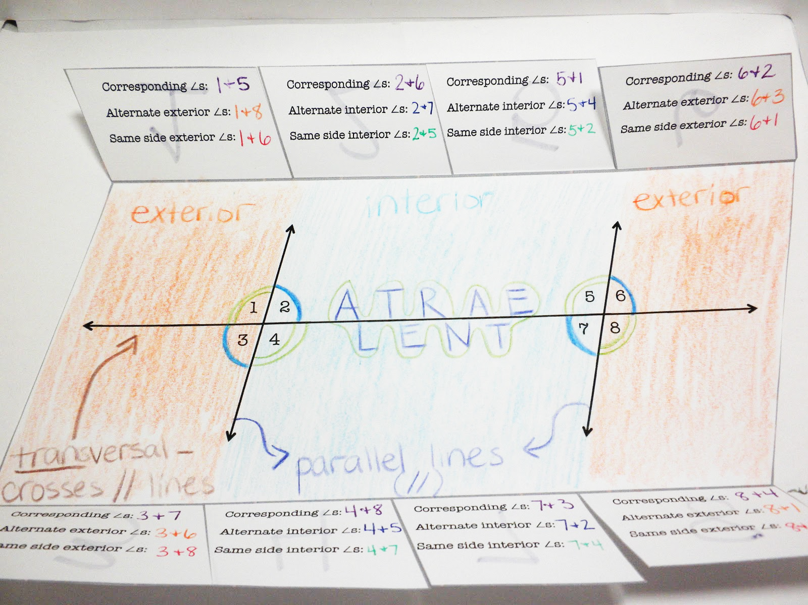

Day 3: Deploying
- Part 1 Initial whole group discussion - setting the scene
  - Teacher will present the students with a parking lot of a mall, however there are no lines. Teacher will say that the mall recently repaved and will paint new lines, but are wanting to change the lines. (2 minutes)
- Part 2 Student group activity/pre-activity (with/without whiteboard)
Whole group discussion of part 1 activity - conclusions to be drawn from discussions about activity - these may be only qualitative or just introducing the “big ideas” - being developed by the students, with teacher guidance.
  - Teacher will show where the boundaries are, give them a scale of how big a car is, and have them develop a model of a potential parking lot. Students will be told that the parking lot should be able to park between 300 and 350 cars. (5 minutes)
- Part 3 Student group activity (with/without whiteboard)
Whole group discussion of part 1 activity - usually a quantitative proof of the “big idea(s); conclusions to be drawn from discussions. These become mathematically quantitative - verified by the student-acquired data.
  - Students will work with a partner designing the parking lot. Students will focus on drawing the lanes for the cars to drive through, the space for the cars to pull into to park, and the entrances into the parking lot. (20 minutes)

- Part 4 Student group follow-up activity - there might be several of these, as the topic is extended in the unit....
  - Teacher will have students hold up boards to show similarities and differences. (5 minutes) If they haven’t done it already, students will label the angles formed by the lines, add arrows for where the cars should drive, and create a key to show examples of the angle relationships using the foldable on the previous day as a guide. (10 minutes)
- Part 5 Final discussion (with/without whiteboard)
Generalizations, connections to other math topics, connections to real life
  - Students will display their boards and students participate in a gallery walk. (8 minutes)

- Brief summary of how this unit fits into year’s curriculum and storyline (e.g preceding and post activity/units)

